brick-by-brick…

LEAVE A LASTING MESSAGE ON CAMPUS AND HELP US BEAUTIFY THE BIG PLAYGROUND!

*If you are ordering more than two bricks, please include additional message/s on the back of this form. Please return to the School Office.*

**Write your message/s here. PLEASE PRINT CLEARLY:**

|  |  |  |  |
| --- | --- | --- | --- |
| **Total Number of Bricks:** |  | **Total Amount Due (No. of Bricks x $50):** |  |

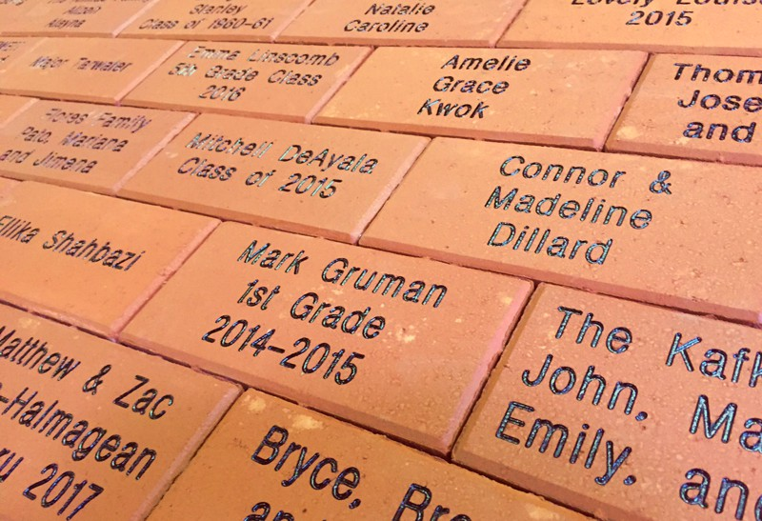

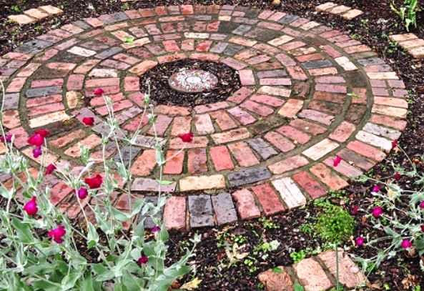

Payment Information:

Your Name _______________________________ Your E-mail ________________________________________________

Cash, in the amount of $___________________ is attached.

A check, made out to ‘Paddington Station Preschool’ for $________________ is attached. Check number: ____________.

🞏 Please charge $______________________ to my credit card that is currently on file at the school.

🞏 Please charge $____________________ to the following credit card (this order form will be placed in a lock box):

Card type______________________ Card number__________________________________ Expiration date___________.

